Ring Light PCB Project Notes
Christopher Kalitin

Apr 28 2025 - Breadboard Testing

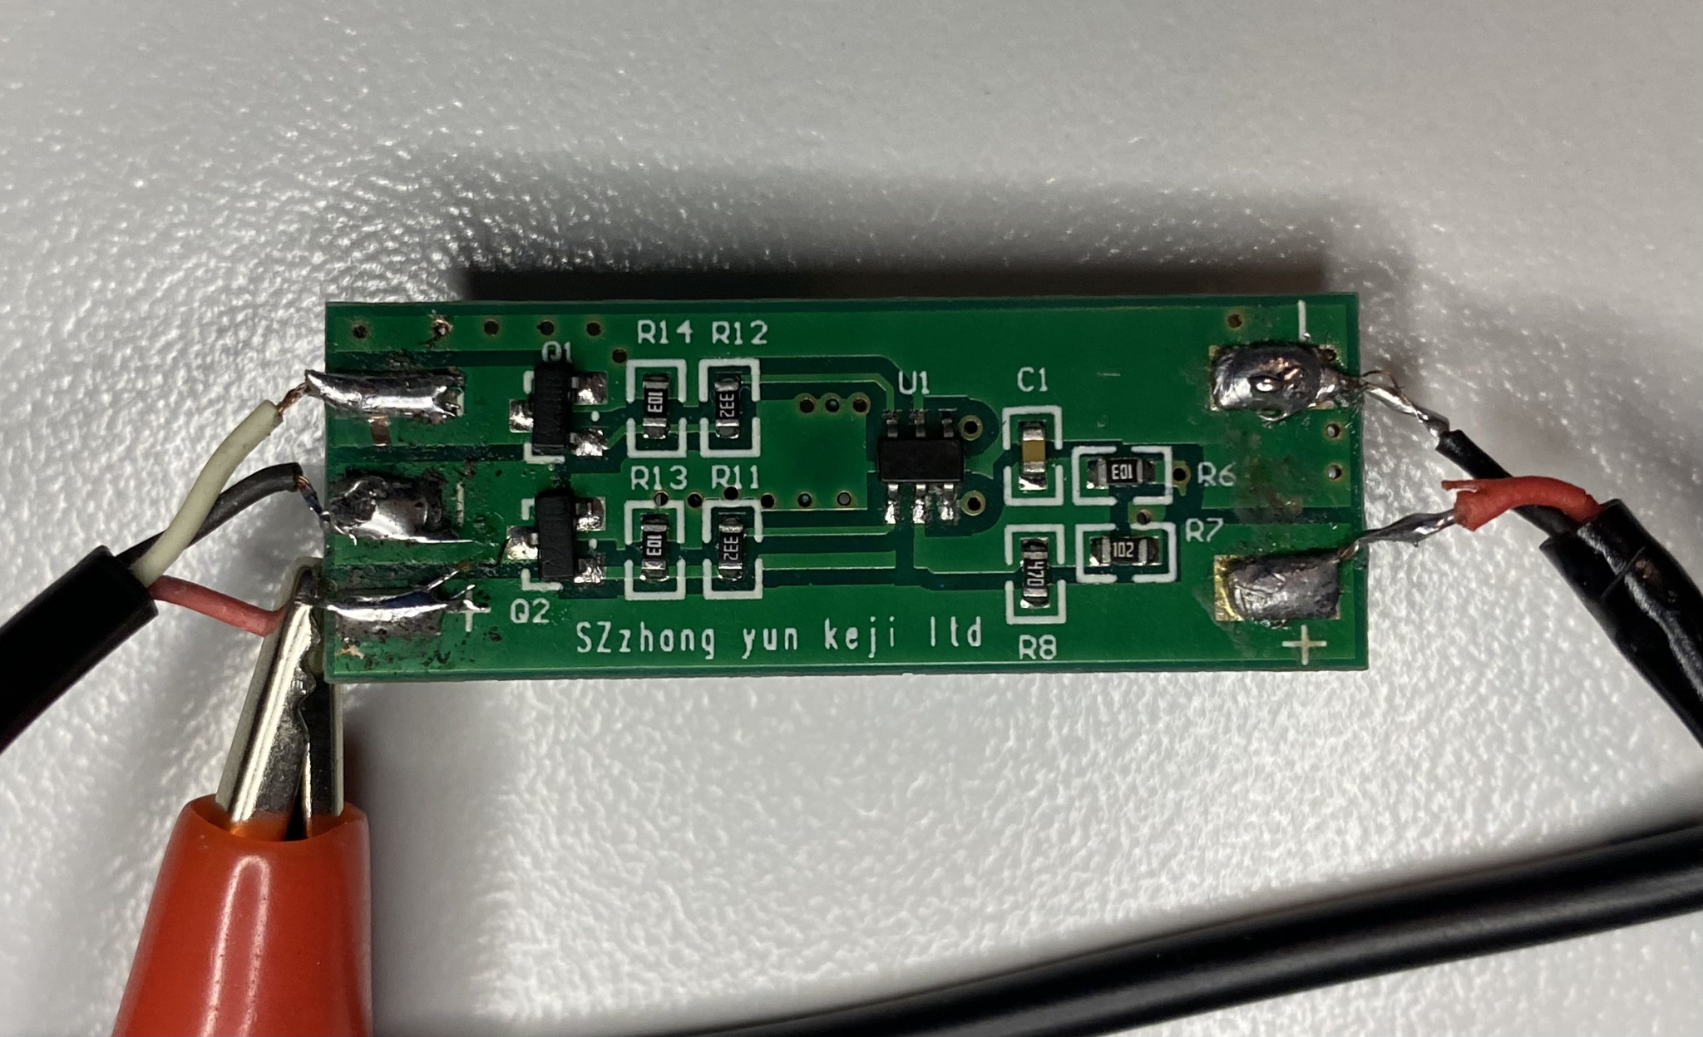

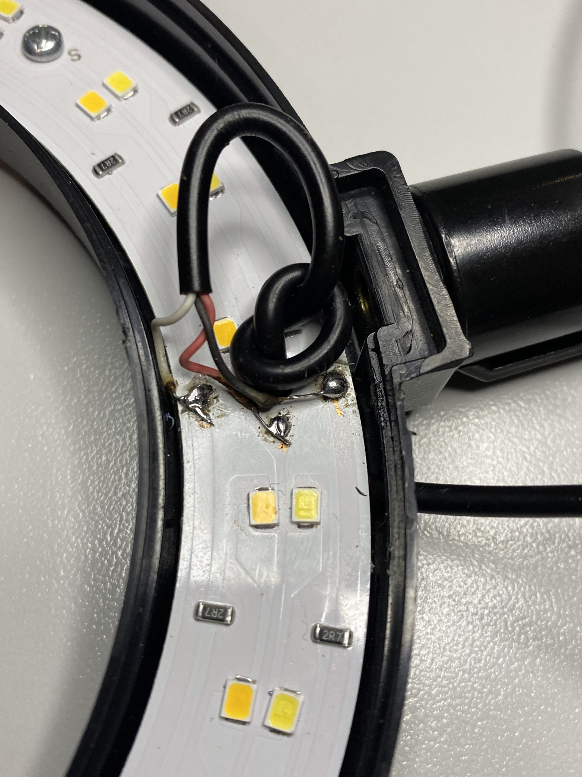

The red wire is the positive voltage.
Black is the ground for the white LEDs (outer ring).
White is the ground for the yellow LEDs (inner ring).

It uses black and white as ground offsets, so increasing their voltage through a potentiometer makes the voltage difference over the LED lower, decreasing brightness.
No difference in brightness between a 10k and 50k potentiometer.

Positive is 4.9V from a PC USB port. Most of the brightness scale of the LEDs is around 0V for the reference ground. Going to even 0.5V means most of the luminosity. In other words, with less than 4.4V voltage across the LEDs, they don’t make much light.

Will need to use a voltage divider to remedy this, it’d be a bad user experience to have 90% of the potentiometer range do nothing while the difference between 100% and 95% is most of the brightness. It’s the shower knob problem.

Brightness vs. Voltage of Reference Ground by eye:
2.63V - 0%
2.18V - 10% Knee in graph
1.64V - 50%
0.6V - 90%
0.06V - 100%

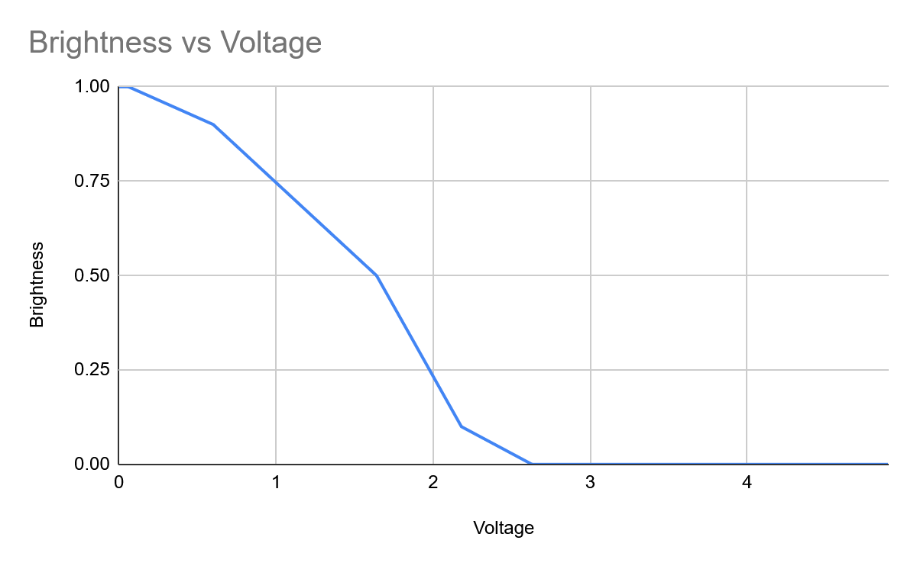

These chinese manufacturers had to account for the shape of that curve when they decided the step size between their hard coded brightness values (they use up/down buttons not pots).

Simple 10k pot 10k resistor voltage divider will do the trick here.

With a 50k res and 50k pot the current is too low so you get really weird non linearities.

Very non-linear relationship between the potentiometer turns and voltage. It sits around 2.62-2.44 for a while, then sharply drops to 0.66 on the last little bit of a turn

See:
https://grok.com/chat/d2ca07f3-6b7d-4a4e-9537-835c50306f98
https://chatgpt.com/c/68105eac-df40-8006-ab48-57aa82d7ccc9
Yea grok was too much of a wordcel yapper so I got chat to do it

Switching to 50 ohm res and 50 ohm pot solved it, until res heated up enough that i couldn’t touch it for more than a second (chat warned). The solution is either a bigger res and pot, or PWM. Will try PWM tomorrow. PWM from an STM32 or from an IC for it. Probably best to do it with STM32.

Apr 29 2025 - PWM Testing
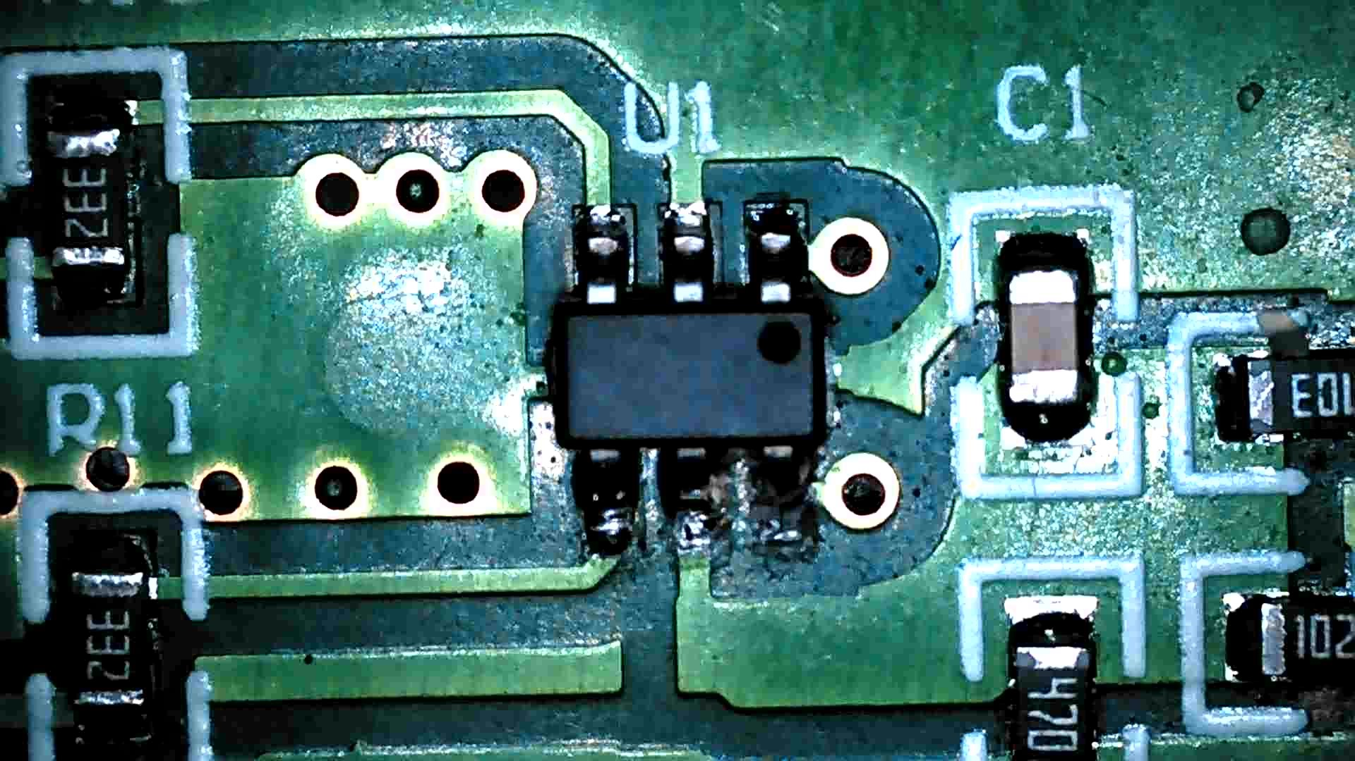

The IC on the board is completely unlabeled.

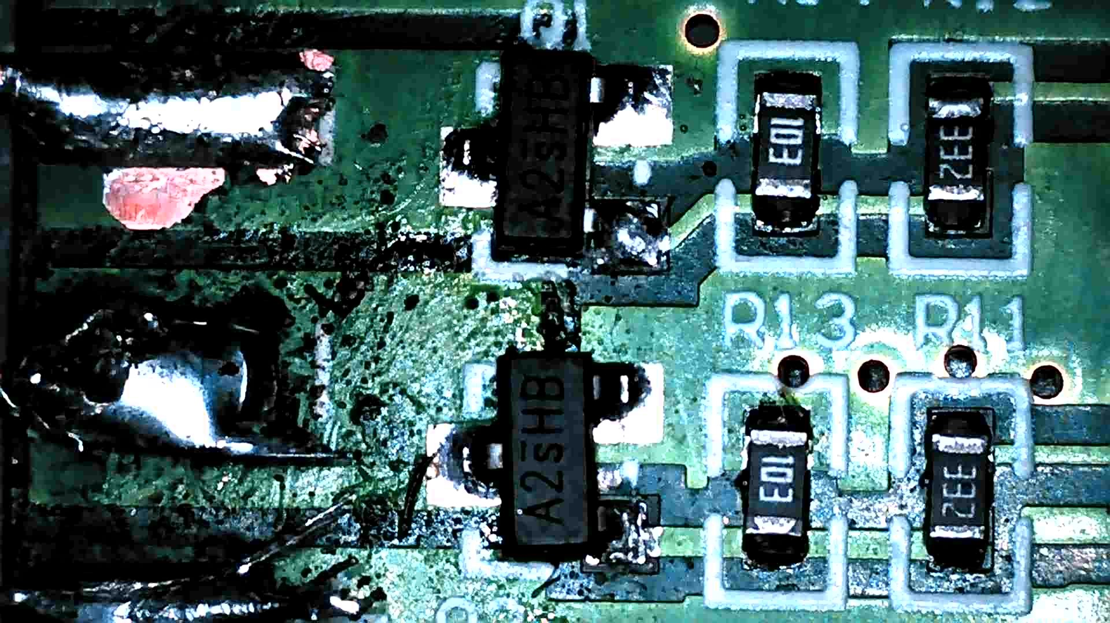

A2sHB

Low side switching with an n channel is resulting in 0.68V as the ground voltage, we expect 0V. Maybe it’s configured incorrectly, will try high side after breakfast.

I have no clue what’s going on.
I have about 120mA draw by the LEDs, there’s a big voltage drop over the 5V line (USB from my PC), and MOSFET drain (LED ground) never gets below 0.6V.

I’ll watch videos / read up on LED driver circuits.

